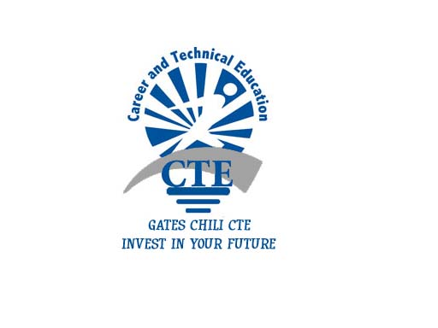**CTE: Questions & Answers**

Gates Chili High School

BUSINESS DEPARTMENT

# Gates Chili

**Career**

**&**

**Technical**

**Education**

**Program**

**What will a CTE Program**

**Endorsement do for you?**

…Prepare you for a high-skill, high wage,

high Demand occupation in our 21st

century global economy.

**Who can enroll in a CTE**

**Program?**

…All CTE programs are designed to ensure

**Academy of Financial**

**Management**

**Be better prepared for college entrance**

**Earn college credit**

**Gain 21st Century work skills**

student success and prepare students for

post secondary education and/or the work

force.

**Is completing a CTE Program**

**overly demanding or difficult?**

…No! While CTE programs are rigorous

courses of study, they are not overly difficult

and by taking 1-2 electives each year

students can complete a program and receive

an **Advanced Regents** designation on their

diploma.

**How can I earn college credit by**

**taking CTE Courses?**

…Simply select the courses that qualify for

Gates Chili Central School District

Gates Chili High School

Business Department

www.gateschili.org

247-5050 ext. 2333

Dual Credit.

Gates Chili Central School District

3 Spartan Way

Rochester, NY 12624

Phone: (585)-247-5050

Fax: (585)-340-5594

http://www.gateschili.org

*College fee may apply.

*College credits are transferable.

**Financial Management CTE Course Sequence**

**Mandatory 1 Credit**

(.5)Career and Financial Management

(.5)Wall Street 101 – (MCC Dual Credit)

**Choose 2-3 Credits**

(1)Accounting 1 (MCC Dual Credit)

(1)Marketing and Management (MCC Dual Credit)

(1)College Accounting (MCC Dual Credit)

**Choose 2 ½-3 Credits**

(1)Math with Business Applications

(.5)Computer Applications – MOUS cert, (MCC Dual Credit)

(.5)Keyboarding/Web Communications

(MCC Dual Credit)

(.5)Sports and Entertainment Marketing

(.5)JA Economics (MCC Dual Credit)

**Mandatory 1 Credit**

(1)Work Based Learning (COOP, 3 Job Shadows, or Internship)

**Assessments** - NOCTI/ CLEP – Business Financial Management

**Final Project and Presentation**

**How to Sign up for Financial Management CTE**

* See your Counselor
* See if you have already met any of the requirements
* Add CTE Courses to your schedule
* See if you can take any CTE courses online or supplemental if your schedule is full

**Technical Endorsement on Diploma**

Students enrolled in an approved career and technical education (CTE) program who successfully complete all requirements earn a technical endorsement to be affixed to their high school diploma.

**Gates Chili Business CTE Program**

Career and Technical Education  
  
**Features:**

* Career exploration and identification
* Real-life business problem identification and resolution
* Dual credit with MCC available
* Business skill development
* **Earn up to 21 Credits at MCC**

**Requirements:**

* Five Business course credits
* Five Regents Exams
* Work-Based Experience
* Successful completion of Financial Management NOCTI exam.

business people and office building

**Academy of Financial Management CTE**

A Financial Management CTE program contains a related and continuous combination of courses and experiences in the field of Business and Finance.   It is designed to provide students academic and technical knowledge and skills in preparation for further education/training and/or employment in a business or finance. The program is taught by appropriately certified and qualified teachers and is supported by work-based experiences, a Work-Skills Employability Profile, technical assessments and data on student performance in academic and technical areas.

For information on open positions or to submit your resume, please visit our Web site at: www.lucernepublishing.com